**EMAIL FROM HR TO EMPLOYEES**

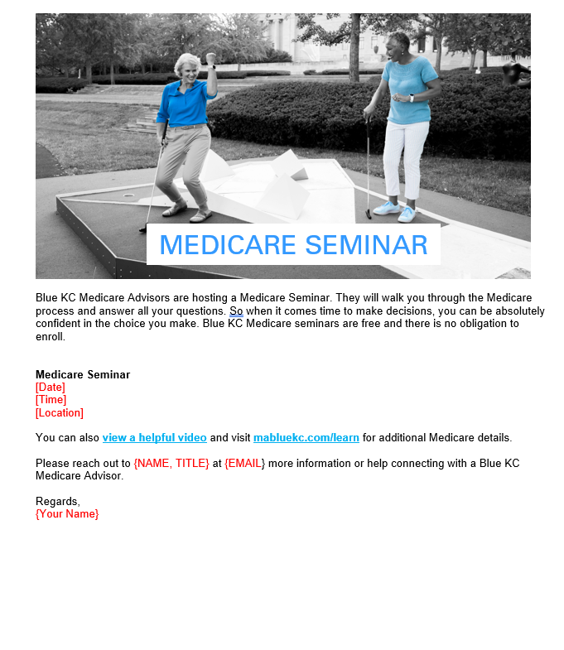 ***Instructions for HR***

* There are two email header images on the following page that you can use at the top of your email. Simply drag and drop the image into your email.
* You will find our suggested subject line and copy for the email on the following page.
* Simply copy and paste both the image and the copy into MS Outlook. If you’re using another email distribution method, some reformatting may be required.
* For further information on how to send a bulk email to multiple contacts through Outlook please reference this easy how-to guide: <https://bit.ly/38AkcQJ>
* When copying and pasting the content, we recommend you keep the source formatting. For tips on formatting, please refer to this handy link: [view here](https://www.microsoft.com/en-us/microsoft-365/blog/2012/02/10/tip-how-to-cut-and-paste-without-messing-up-formatting/)

***Visual Reference for Copy Layout***

We recommend formatting the email text body copy to the following styles:

Arial, Regular 12pt | Black Text Color: # 000000

**If you have any additional questions about the content, please contact your broker or Blue KC representative.**

*Email Header Image Option 1:*



***Email Subject Line***

**Attend an upcoming Medicare Seminar**

*Body Copy:*

Blue KC Medicare Advisors are hosting a Medicare Seminar. They will walk you through the Medicare process and answer all your questions. So when it comes time to make decisions, you can be absolutely confident in the choice you make. Blue KC Medicare seminars are free and there is no obligation to enroll.

**Medicare Seminar**

[Date]

[Time]

[Location]

You can also view a [**helpful video**](https://youtu.be/pxD3Kb36hVY) and visit [**MedicareBlueKC.com/learn**](MedicareBlueKC.com/learn) for additional Medicare details.

Please reach out to {NAME, TITLE} at {EMAIL} more information or help connecting with a Blue KC Medicare Advisor.

Regards,

{Your Name}